Rxjs version 6 is out. Angular 6 uses it by default. RXjs has some breaking changes. This is why-

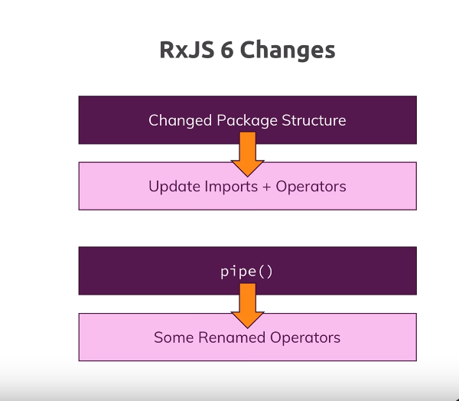

So first they changed the package structure to reduce bundle size, so you have to change your imports. Other change is how we use operators. They introduced pipeable operator. Now we use operators in different way. This also led to renaming some operators, we will see why.

Changed imports-

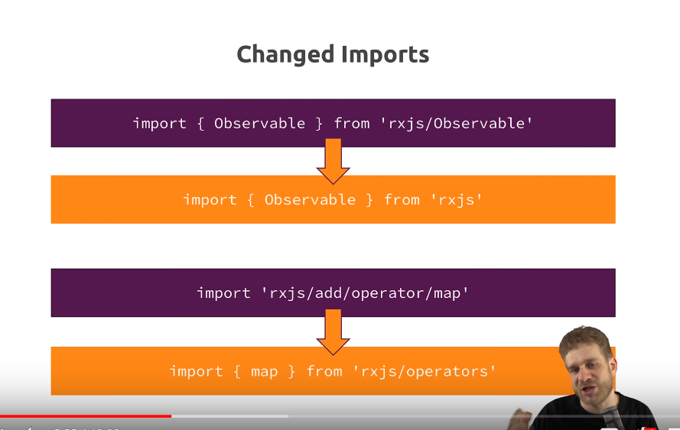so Observales, Subjects are imported like this, as shown in first import. Then it shows how to import operators. This is how observable imports changed-

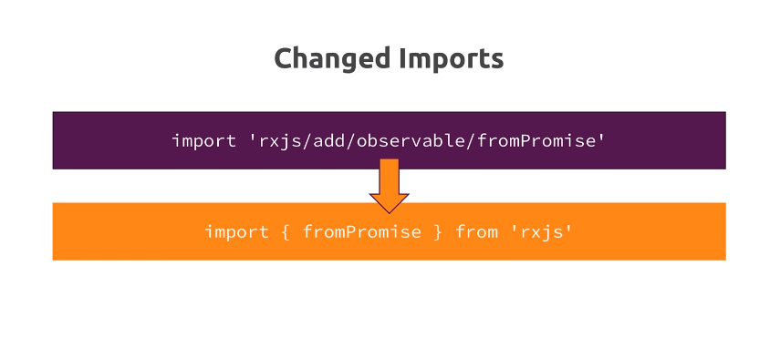now we got pipeable operators. Which means, this change-

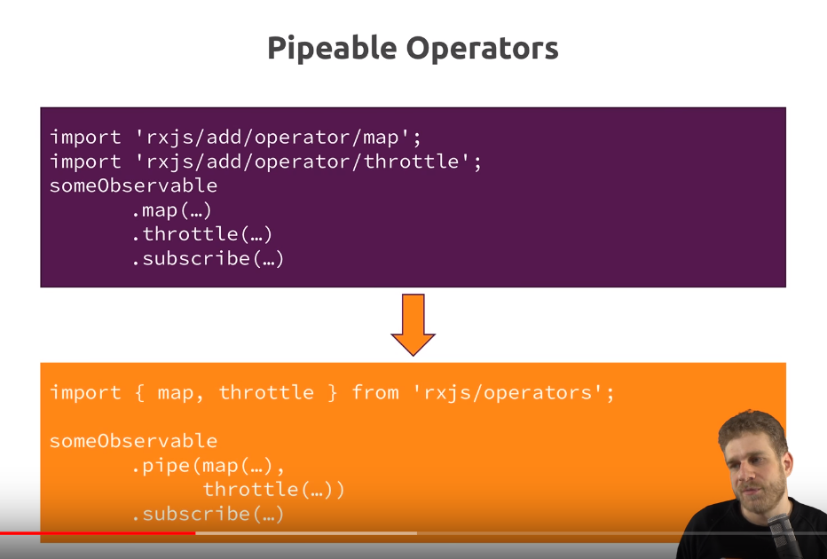now we will not chain operators, in RXJS 6 and in future updates, we will use pipe to apply multiple operatots. Now due to this pipeable operators, some operatrs needed to be renamed because tey clashed with reserved keywords in js because we are not calling them as methods anymore , now they are normal functions, so they must not be renamed like javascript keywords. Following operators were renamed-

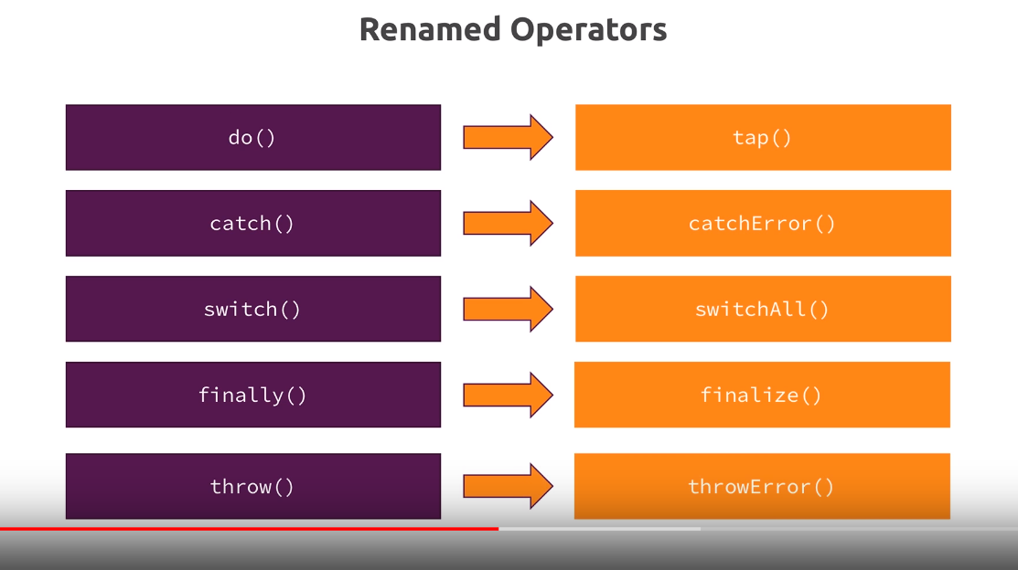last one is not an opearator but it is a method that allow us to create observables, which you could also chain to observable object in past becomes stand alone method like all observable creation method.